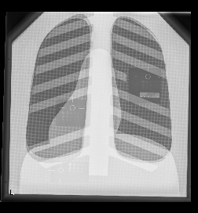

Educational manual for Digital Phantom "Duke"
07-646 QC Phantom for Digital and Conventional Chest Radiography

The purpose of this document is to provide a starting point for course material of a practical training being part of the education for technologists and/or medical doctors involved in X-ray imaging. The intended audience includes instructors/trainers for such course.

This document intended to show aspects of image quality related to patient dose for a digital X-ray imaging system. The process of optimizing the dose versus image quality is not only beneficial for the patient, but also for the personnel.
The dynamic range of modern digital X-ray systems is much larger compared to the old film-screen systems. The result is that over-exposure is virtually impossible. This might result in an increase of the patient dose. On the other hand, an underexposure results in a noisy image that is not optimal for diagnosis. Therefore the image exposure should be optimized with respect to image quality and patient dose. Furthermore technologists and radiologists should have some knowledge about optimizing the kV for imaging of specific body parts. The experiments described in this document intend to show the mechanisms involved.
In addition, the phantom can be used for training in fluoroscopy, where it may be demonstrated that small objects with high contrast such as screws and catheters can be localized on low-quality images (i.e. low tube current). This aspect is not described in this document, though the last experiment may serve as an example.

Educational targets:
- General
  - To demonstrate how exposure parameters (kV and mAs, focal spot size, ‘speed’) influence image quality and patient dose
- Specific
  - To demonstrate the relation between kV and thickness of imaged tissue and the resulting image quality
  - To demonstrate how the choice of kV relates to patient dose
  - To demonstrate the effect of detector ‘speed’ on image quality
  - Relation between high contrast spatial resolution and focal spot size
  - The effect of setting the correct diaphragm on patient dose and image quality
  - The effect of a grid on patient dose and image quality

Equipment:
- 07-646 QC Phantom for Digital and Conventional Chest Radiography (“Duke Phantom”)
- DR or CR X-ray imaging system
- Equipped with a dose area product (DAP) meter or a separate dose meter to measure the entrance dose

Supertech, Inc. P.O. Box 186 - Elkhart, IN 46515-0186 - Phone: 574-264-4310 / 800-654-1054 Fax: 574-264-9551 - E-mail: sales@supertechx-ray.com - Web Site: www.supertechx-ray.com

Experiment 1: exploring the effect of kV on tissue contrast.

Materials & methods:
- Duke Phantom
- Dose meter in case X-ray generator is not equipped with DAP meter

Description:
The phantom has three low contrast resolution inserts [fig]: one in the ‘lungs’, one under the ‘heart’ and one under the ‘liver’. The phantom absorption in these areas approximates the true tissue absorption in a human patient.

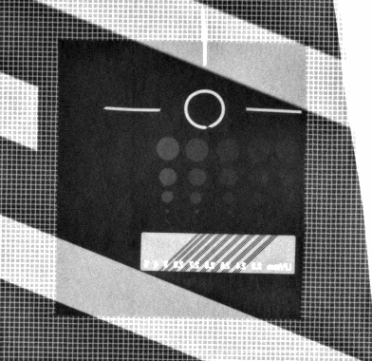 | 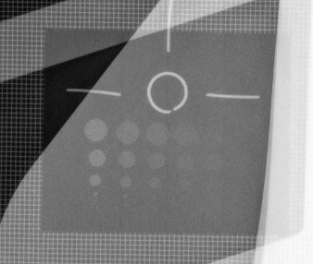 | 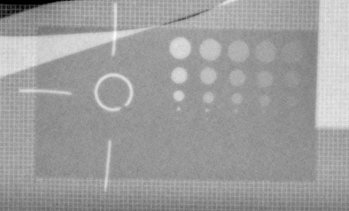
lungs | heart | liver

Exposure parameters:
- body part: “thorax”
- field size: 43 cm x 43 cm
- focus-detector distance: 110 cm
- grid: in
- automatic exposure with two side fields (central field switched off)
- speed: 400
- kV: 50 – 150 kV in 20 kV-steps

Example table with results of experiment:
kV | mAs | Exposure index | DAP [uGy/m²] | # of circles visible on low-contrast resolution insert
 |  |  |  | lung | heart | liver
50
70
90
110
130
150

Supertech, Inc. P.O. Box 186 - Elkhart, IN 46515-0186 - Phone: 574-264-4310 / 800-654-1054 Fax: 574-264-9551 - E-mail: sales@supertechx-ray.com - Web Site: www.supertechx-ray.com

Questions:
a: how is the visibility of low contrast in the lung (number of circles visible) compared to the heart and the liver at 50kV?

Answer: visibility of low contrast in lung is better than in the heart – which in turn is better than in the liver.

b: how does visibility of low contrast in the lung at 50kV compare to 90kV and 150kV?

Answer: not much difference

c: same question for heart en liver?

Answer: low contrast less visible at 50kV

d: now let’s look at the patient dose: how does the entrance dose relate to the kV setting?

Answer: entrance dose at 50kV is exceptionally high!!!

e: which kV setting gives the optimal image quality in all areas?

Answer: around 110kV

f: is the radiation exposure reasonable for this setting?

Answer: calculate the entrance dose from DAP to answer this question, and compare to other modalities such as CT, and to natural background radiation.

Example exposure data
(13/6/2007, Siemens Axiom Aristos FX, Amstel Academie VU, #5999205 FANTOOM_MrDuke)
 | kV | mAs | Exposure index | DAP [uGy/m²] | # of circles visible on low-contrast resolution insert
serie |  |  |  |  | lung | heart | liver
3 | 50 | 84 | 126 | 212
4 | 70 | 5.9 | 171 | 41
5 | 90 | 1.8 | 225 | 18
6 | 110 | 1.0 | 257 | 13
7 | 130 | 0.6 | 269 | 9.6
8 | 150 | 0.5 | 310 | 8.4

Supertech, Inc. P.O. Box 186 - Elkhart, IN 46515-0186 - Phone: 574-264-4310 / 800-654-1054 Fax: 574-264-9551 - E-mail: sales@supertechx-ray.com - Web Site: www.supertechx-ray.com

Experiment 2: Exploring image quality keeping the patient entrance dose constant.

Materials & Methods: see Experiment 1

The standard kV setting for a thorax X-ray is 110kV. The target of this experiment is to demonstrate why this is the case, and not 50kV.
In the previous experiment the tube charge (mAs value, determined by the automatic exposure) of the 50kV exposure was much higher than the 110kV exposure. The target now is to make a manual exposure with 50kV, using approximately the same DAP (or entrance dose) as the 110kV exposure in experiment 1.

First answer question a and then make the exposure and evaluate the image quality by counting the number of circles visible in the three organs. Present your results in a table.

Questions:
a: how would you estimate the mAs setting for the manual exposure?

Answer: mAs and DAP have an approximately linear relationship when all other parameters are kept constant. Thus: mAs = [mAs@50kV in experiment 1] * [DAP@110kV in experiment 1] / [DAP@50kV in experiment 1]

b: how does the image quality compare to the 110kV exposure with identical entrance dose, taking the three organs into account?

Answer: lung: rather comparable with 110kV, heart and liver: much better at 110kV.

c: how would you explain the above observations?

Answer: the 50kV X-ray spectrum has a lower penetration depth compared to the harder X-ray spectrum of 110kV. Lung tissue has little mass to absorb the X-rays and therefore even the 50kV X-rays will pass though to the detector, leading to registration of an image on the detector. However, the liver has more mass, and absorbs most of the 50kV X-rays. The 110kV X-rays still get through to form an image.
In conclusion: one needs enough kV to get through the mass, but if kV is set too high, the image contrast gets lower because some absorption is needed for image contrast.

Example exposure data
(13/6/2007, Siemens Axiom Aristos FX, Amstel Academie VU, #5999205 FANTOOM_MrDuke)

 | kV | mAs | Exposure index | DAP [uGy/m²] | # of circles visible on low-contrast resolution insert
serie |  |  |  |  | lung | heart | liver
6 | 110 | 1.0 | 257 | 13
9 | 50 | 3.2 | 7 | 11
10 | 50 | 4.0 | 8 | 14

Supertech, Inc. P.O. Box 186 - Elkhart, IN 46515-0186 - Phone: 574-264-4310 / 800-654-1054 Fax: 574-264-9551 - E-mail: sales@supertechx-ray.com - Web Site: www.supertechx-ray.com

Experiment 3: effect of focal spot size on the image resolution

Materials & methods:
- Duke Phantom

Description:
To demonstrate the effect of the focal spot size on resolution and exposure time.

Exposure parameters:
- body part: “thorax”
- field size: 43 cm x 43 cm
- focus-detector distance: 50 cm and 200 cm
- focal spot size: small and large
- grid: in
- automatic exposure with two side fields (central field switched off)
- speed: 400
- kV: 110 kV

Make two identical exposures using a focus-detector distance (FDD) of 50 cm, using the automatic exposure control, one with small focal spot, and one with a large focal spot.
Write down the exposure time, and check what the maximum tube current (mA) is that the generator allows you to choose.
Then increase the FDD to 200 cm and repeat the above.

Questions:
a: can you see any difference in the resolution of the images with FDD 50 cm? (hint: check the visibility of smallest disks in the lung insert). Is this also visible at FDD 200cm?

Answer: the focal spot size determines the spatial resolution of the system together with the resolution of the detector.

b: In which case would you want to use a large focal spot size?

Answer: the maximum tube current is limited for the small focal spot. In case the FDD is large and the body part of interest is dense (e.g. hip) you will need a high mAs. The exposure time can become a limiting factor in such cases because unsharpness due to subject motion.

Supertech, Inc. P.O. Box 186 - Elkhart, IN 46515-0186 - Phone: 574-264-4310 / 800-654-1054 Fax: 574-264-9551 - E-mail: sales@supertechx-ray.com - Web Site: www.supertechx-ray.com

Experiment 4: effect of detector ‘speed’ at 110kV

Digital systems allow setting the ‘film speed’ of a digital detector when using the automatic exposure control. The ‘speed’ setting controls the target dose on the detector and therefore the image quality in terms of noise. This experiment shows the effect of the ‘speed’ setting on the low contrast visibility.

Materials & methods:
- Duke Phantom
- Dose meter in case X-ray generator is not equipped with DAP meter

Description:
To demonstrate the effect of detector ‘speed’ on the low contrast visibility.

Exposure parameters:
- body part: “thorax”
- field size: 43 cm x 43 cm
- focus-detector distance: 50 cm and 200 cm
- focal spot size: small
- grid: in
- automatic exposure with two side fields (central field switched off)
- speed: variable 200 – 400 – 800
- kV: 110 kV

Make three exposures increasing the speed from 200 to 400 to 800 (or an equivalent setting for your system). Write down the exposure parameters (including DAP and exposure index, or equivalent parameters for your system), and examine low contrast visibility using the contrast inserts.

Questions:

a: does the overall image intensity change? Is the intensity a measure for image quality and is it related to patient dose?

Answer: the overall image intensity is scaled automatically and therefore is not an indication of the quality or the patient dose. Note that this aspect is different from the conventional film-screen systems, because under- or overexposure is not clearly visible.

b: how does the visibility of low contrast (number of visible disks) relate to film speed and patient dose? How is image noise related to speed? Is the exposure index related to image quality and patient dose?

Anwser: lower film speed gives higher patient dose, therefore more X-ray photons on the detector and thus less noise and better low contrast visibility.

Supertech, Inc. P.O. Box 186 - Elkhart, IN 46515-0186 - Phone: 574-264-4310 / 800-654-1054 Fax: 574-264-9551 - E-mail: sales@supertechx-ray.com - Web Site: www.supertechx-ray.com

Experiment 5: effect of diafragm and grid on low contrast visibility

Materials & methods:
- Duke Phantom

Description:
To demonstrate the effect scattered X-rays on the low contrast visibility.

Make three exposures:
1) with grid, field size 43x43 cm, automatic exposure control
2) without grid, field size 43x43 cm, automatic exposure control, write down the resulting mAs.
3) without grid and a small field size (approx 6x4 cm) that just images the contrast insert in the liver, using the same mAs setting as exposure 2.

Questions:
a: Explain the observed differences in image quality assessed by counting the number of visible disks in the liver insert. Also discuss the effect on patient dose of a grid and of a reduction in field size.

Answer: both the grid and the smaller field size reduce the number of scattered photons that reach the detector. Digital systems in general are more sensitive to scattering compared to traditional film-screen combinations.

b: what type of exam would you do without grid and why?

Answer: small objects such as hands, or children can be imaged well without grid because of the low amount of scattering resulting from a small object and a small field size. The grid also reduces the amount non-scattered X-rays that reach the detector and therefore increases the patient dose if it is not needed to reduce scattered X-rays.

Supertech, Inc. P.O. Box 186 - Elkhart, IN 46515-0186 - Phone: 574-264-4310 / 800-654-1054 Fax: 574-264-9551 - E-mail: sales@supertechx-ray.com - Web Site: www.supertechx-ray.com

